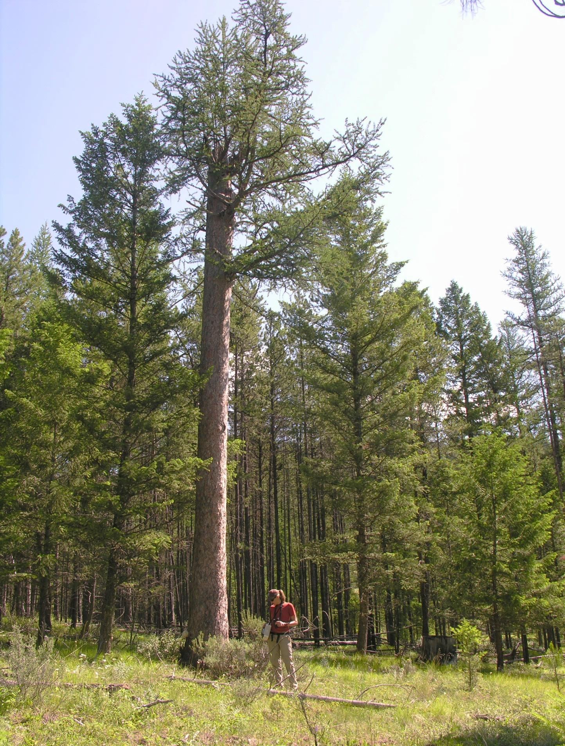

Population monitoring of Williamson’s Sapsucker, Sphyrapicus thyroideus, in the East Kootenay Area of Occupation

by
P. Ohanjanian
L.-A. Isaac
P. Davidson

for

Environment Canada

2012

ACKNOWLEDGEMENTS

Thanks to our excellent field crew, Irene Manley, Shirley Hansen and Jim Beare.

Data on nest re-occupancy for the majority of nests was provided by Ted Antifeau, Min. of Forests, Lands and Natural Resource Operations, Nelson, BC.

We would like to thank the Williamson's Sapsucker Recovery Team and Environment Canada for the opportunity to study these birds once again.

EXECUTIVE SUMMARY

In 2012, a third year of random call playback (cpb) sampling to detect the endangered Williamson's Sapsucker was carried out in the East Kootenay. The objective was to improve our knowledge of the list frame (i.e. known nests) and to randomly sample for birds within the area frame (i.e. habitat within the Area of Occupancy) as recommended in the draft Adaptive Monitoring Framework (Marmorek and Pickard 2010). In addition, birds that responded during cpbs were to be re-located during brood-rearing and their nests located and described. Finally, previously occupied nest trees were re-visited to obtain a measure of nest re-occupancy.

Call playbacks were conducted at 248 random points. Williamson's Sapsuckers were detected at only 8 (3.2%) stations, three of which were of birds on territories already known from previous years. Two stations were combined into one, as they were close together and the detected bird was seen at both. Therefore, only four potential new territories were discovered during random sampling in 2012. No new nests were found at any of these during 24.0 hr of intense searching. An additional pair and the only new nest was found during a survey at a non-randomly selected site near Cranbrook, BC. This nest was in an aspen, with a dbh of 26.5. The nest tree was 520 m from a previously located nest, and may have been occupied by the same pair, but in another part of its territory.

Ten of 40 nest territories were re-occupied (25%). When compared only those occupied in 2011, the 2012 re-occupancy rate was 80%.

It took approximately 285 person hours to survey 248 cpb points in the EK in 2012. A total of 22.18 person hrs were spent accessing points on foot (one way). 5,903 km were driven for cpbs, nest searches and approximately one-third of the nest re-occupancy checks.

Random call playback surveys in the EK failed to significantly improve our knowledge of the list frame in three years of applying this approach. The sampling resolution is too coarse compared to the low density of birds in this region, and little information is being obtained. Several problems have been identified that will compromise our ability to detect population trends in this area. These are:

1. The provisional AO is a large amalgamation of multiple AOs. We lack a clear delineation of the boundaries.

2. There are problems with habitat stratification and model suitability.

i. The vegetation mapping and databases from which the stratification was derived is very inaccurate, and lacks ecological relevance to Williamson's Sapsuckers.

ii. The habitat model may not be suitable. Birds were detected at stations ranked as “low” and ”very low” in the EK. Because of limited productivity data, we do not know if those rankings are appropriate for this region.

iii. Variability within each habitat category provided by Environment Canada is high.

4. Probability of detection is not known here.

Recommendations:

a) Clearly delineate AO boundaries and concentrate monitoring efforts in those areas where there is a higher density of Williamson's Sapsuckers. Apply random sampling over these smaller areas.

b) Repeatedly visit cpb stations to estimate detectability and ultimately find more birds

c) Examine the statistical implications of using an adaptive sampling approach, whereby crew can add cpb stations in areas of higher occupation and therefore, higher p(detection).

d) Find mapping and data sources other than the VRI database to assist in stratification. Use local knowledge during planning and stratification.

e) Refine habitat model for the East Kootenay.

f) Improve on our understanding of population trends by visiting known nests twice: during territory establishment (to determine re-occupancy), and again during brood-rearing (to get a measure of nesting success).

Table of Contents

1.0 INTRODUCTION 1
2.0 METHODS 1
2.1 Call playback surveys and collection of habitat information 1
2.2 New nest searches 2
2.3 Nest re-occupancy 3
2.4 Data management and logistics 3
3.0 RESULTS 4
3.1 Call playback surveys 4
3.2 Nest searches 5
3.3 Nest re-occupancy 7
3.4 Logistics 8
4.0 DISCUSSION 8
4.1 Call playback surveys 8
4.2 New nest searches 10
4.3 Nest re-occupancy 10
4.3 Logistics 11
5.0 RECOMMENDATIONS 11
6.0 LITERATURE CITED 12

List of Tables

Table 1. Definitions for habitat descriptions at cpb stations……………………………………………….……….2

Table 2. Detections of Williamson's Sapsucker during 2012 random sampling. 5

Table 3. Results of nest searches at random cpb stations 6

List of Figures

Figure 1. Locations of Williamson's Sapsucker detections in 2012. 4

Figure 2. Williamson's Sapsucker nest tree, WNE048, near Cranbrook, BC. 6

Figure 3. Male Williamson's Sapsucker at top of western larch vet. 7

Figure 4. Provisional Area of Occupancy for Williamson's Sapsucker in East Kootenay as of 2009 (after Gyug 2010). 9

1.0 INTRODUCTION

In 2010, an Adaptive Monitoring Framework (AMF) was developed to track the status of Williamson’s Sapsucker (WISA) populations where it occurs in three regions in British Columbia (Marmorek and Pickard 2010). These regions are the Okanagan Boundary, the western region (including Merritt) and the East Kootenay (EK). In 2010 and 2011 random sampling using call playbacks (cpbs) in the East Kootenay Area of Occupancy was carried out following procedures and protocols provided by Environment Canada (Ohanjanian et al. 2010; Ohanjanian 2011). In both years, very few WISA were detected using this methodology and it was hypothesized that sampling occurred too late in the breeding season, during incubation, when birds were less likely to respond. Additional survey work was carried out in 2012 to test this hypothesis, locate more Williamson's Sapsuckers, and further test the efficacy of the random sampling approach in the EK. This report provides the results of work completed in the 2012 field season in the EK Area of Occupancy. It also describes limitations of the data collected and offers recommendations for modifications to the protocol for future work.

2.0 METHODS

2.1 Call playback surveys and collection of habitat information

Two hundred and thirty six random points, plus an additional twenty “Extra” points located in seedtree cuts (total = 256 points) were provided by Environment Canada and uploaded to GPS units and Google Earth. Points had been pre-classified as “Low” or “Very Low” quality habitat after Gyug (2010).
The protocol used for cpbs was based on the methodology developed by L. Gyug for the Forest Investment Account (FIA 2006). Upon arrival at a random point, the observer listens passively for 30 seconds to detect spontaneous drumming or calling. Then, a CD recording consisting of 2 drums followed by several cheeur calls and scold/alarm calls is broadcast using a TOA ER-604W megaphone in 3 directions, with 20 seconds of silence between each 10 seconds of playback. After the broadcast, the observer listens for 3 minutes before moving on to the next cpb station. Call playbacks took place between April 15 and May 15, 2012, to coincide with the time when Williamson's Sapsuckers are most detectable, during territory establishment and nest building. Environmental conditions (wind speed, cloud cover and precipitation) and the time were also recorded. Surveys were suspended during rain showers or when wind speeds exceeded Beaufort 4 (20-29 km per hr).

To assist with efficient navigation in the field, Google Earth images with the cpb stations were pasted into Word documents for each given survey area. A laptop with this file was taken into the field and, using an inverter, consulted along with a GPS. Although it required more office time, this method saved time in the field and was more reliable and efficient than depending on maps and GPS units alone.

When a Williamson’s Sapsucker was detected, the distance and direction from the cpb station was recorded to aid in future nest searches. In addition, the type of detection, visual, call or drum, was noted. All suspect drums and calls were followed up with a visual confirmation of the species, sex, and behaviour.

Stand structure, as provided by Environment Canada, was recorded for each cpb station. The habitat codes and their associated descriptions were as follows (Table 1):

Table 1. Definitions for habitat descriptions at cpb stations.

Code | Description
MatFor | Mature Forest w/o previous harvest
MatFor/h | Mature Forest w/previous harvest as evidenced by very old (rotten) stumps
PartCut>5 | Partial cut >5 years old based on "not fresh" stumps
PartCut<5 | Partial cut <5 years old based on hard and recent stumps
Burn | Fire
CC | Clearcut
CCRES | Clearcut w/ reserves
ST Cut | Seedtree cut
Other | Other-

2.2 New nest searches

Nest searches were conducted at cpb stations where Williamson's Sapsuckers were detected. This involved returning to the station in June, and again broadcasting calls and drums to elicit a response. If an adult was observed, we followed the bird until we could ascertain the nest location. Watching for Williamson's Sapsucker adults foraging on boles of trees and flying with prey items to and from the nest was considered to be the best method as Williamson's Sapsuckers are easily seen when they are making regular foraging trips to feed young. A second method involved two to three persons walking parallel lines, stopping every 10 paces to listen for begging calls. Survey effort was recorded. Nest searches were also carried out where Williamson's Sapsucker had been observed incidentally.

Nest tree data included location (UTM coordinates in NAD83), tree species, Wildlife Tree Class (WTC), approximate tree height, nest aspect, nest height, decay type, and diameter at breast height (dbh). Habitat description for nests included topographic description, macro-site position and aspect, elevation, BEC variant, soil moisture regime, and site series (Braumandl and Curran 1992). The presence of large, old trees (vets) within 50 m, canopy tree species, structural stage and crown closure were also recorded.

2.3 Nest re-occupancy

Nest checks at previously occupied nest trees were carried out by Ted Antifeau (27 nests), by our team (14 nests) and by both parties (5 nests), for a total of 46 nests that were checked for occupancy. Three nests (WNE006 (US nest), WNE037, (I Block) and WNE047 were not checked. Occupancy data from the two sources have been combined in the Excel spreadsheet that accompanies this report.

2.4 Data management and logistics

Data were entered into the Excel spreadsheet (Wildlife Species Inventory or “WSI” template) provided. Logistics information, including no. points /day, mileage, time to walk in, etc., were recorded and summarized.

3.0 RESULTS

3.1 Call playback surveys

Call playbacks were carried out at 248 of the 256 random points. Williamson's Sapsuckers were detected at only 8 (3.2%) of these points (Figure 1), representing 10 different birds (Table 2). Pairs were observed at 3 stations (R12ELR004, R12ELR087 and EXTRA12E05). The female at EKTRA12E05 was also observed at R12ELR062, which was only 360 m away. This female was counted only once because of the close proximity between the stations.

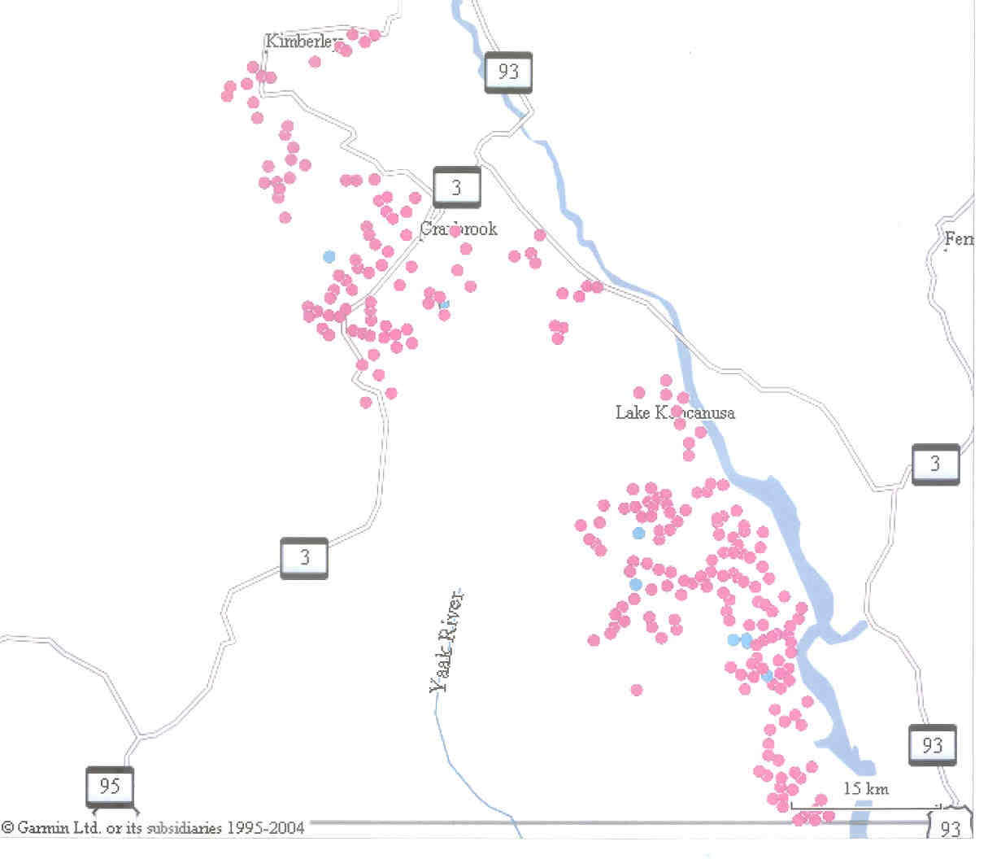
N
EVR182

ELR004

ELR087

ELR069

ELR062
EXTRA12E05
ELR118

Non-random

ELR032

LEGEND

Random cpb point

Point with WISA
Detection

New nest

Figure 1. Locations of Williamson's Sapsucker detections in 2012.

Detections at R12ELR004, R12ELR032 and R12ELR087 were of birds on territories that were occupied in previous years (Ohanjanian et al. 2006, 2008; T. Antifeau, pers. comm.), and nesting there was again confirmed in 2012 (Table 2). Therefore, only four potential new territories were discovered during random sampling in 2012.

Table 2. Detections of Williamson's Sapsucker during 2012 random sampling.

CPB Station | Date | Sex | General Location | Habitat
R12EVR182 | Apr 18 | Male | S. of New Lake  Elev: 1200 m. | Seed tree cut
R12ELR118 | May 5 | Male | West of Plumbob Mountain, and south of Teepee Creek.  Elev: 1320 m. | Larch with sapsucker-sized holes at edge of block in mature forest, previously harvested.
R12ELR069 | May 11 | Female | In valley bottom, 3.7 km south of southernmost Chain Lake.  Elev: 920 m. | Partial cut >5 yrs old, with larch leave-trees
R12ELR062/EXTRA12E05 | May 11 | Male Female | On bench, 3.8 km southeast of the southernmost Chain Lake.  Elev: 1060 m. | Recent clearcut with reserves and seed tree cut.
R12ELR004 | May 7 | Male  Female | Plumbob Burn  Elev: 1240 m. | Burn, 200 m from  WNE030
R12ELR032 | May 3 | Male | Upper Kiahko  Elev: 1320 m | Seedtree cut, 200 m from WNE019
R12ELR087 | Apr 23 | Male  Female | Linklater FSR/Davis Meadow Branch 2  Elev: 920 m | Partial cut, 250 m from WNE013
Note: Italicized entries represent birds on previously occupied territories that responded to cpbs again in 2012

In addition to the birds detected at random stations, one pair was located at a non-random station established in habitat that was deemed suitable by the surveyor (P. Davidson). This non-random site was located in South Star trails south of Cranbrook, BC (Figure 1).

3.2 Nest searches

One new Williamson's Sapsucker nest (WNE048) was found during follow-up nest surveys of the pair found at the non-random point in South Star trails (Figure 1). The nest was located approximately 520 m north east of WNE034. It is not known whether this was the same Williamson's Sapsucker pair on another part of its territory.

WNE048 was in an aspen with heart rot (WTC 2) and a dbh of 26.5 cm. The nest was 5.5 m above ground and had a north aspect (20º). The elevation was 1182 m in the MSdk BEC zone (Braumandl and Curran 1992). Soil moisture regime was hygric (Site Series 04). Vegetation within approximately 50 m of the nest tree was dominated by aspen and western larch. The structural stage was “Mature” and crown closure was 30%.

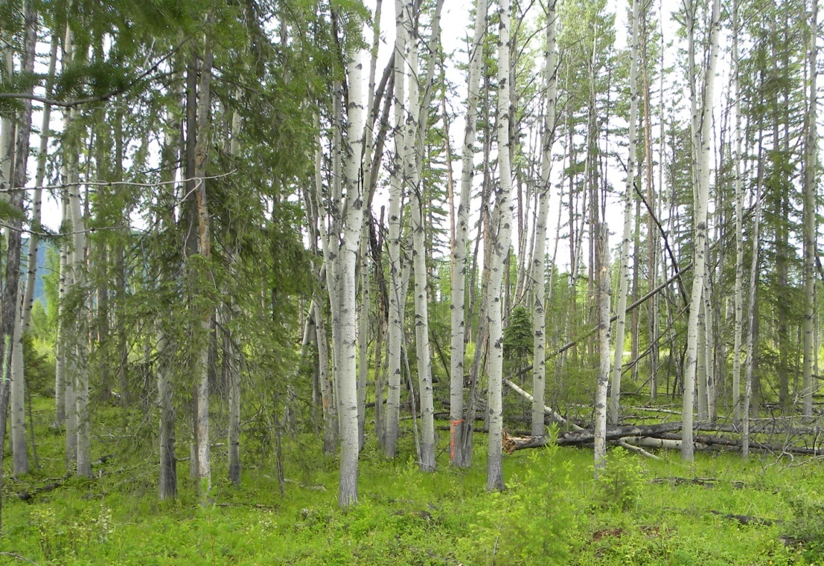

Figure 2. Williamson's Sapsucker nest tree, WNE048, near Cranbrook, BC.

A total of 24.0 person hours were spent searching for nests at the four potential new territories identified during random cpb surveys. These surveys failed to locate new nests (Table 3).

Table 3. Results of nest searches at random cpb stations.
CPB station | Survey  dates | Search time  (pers. hrs) | Birds observed
ELR182 | Jun-19 | 2.1 | Null
ELR118 | Jun-21  Jun-30 | 5.2  0.8 | Null  Null
ELR069 | Jun-20  Jul-04 | 4.2  3.8 | Male  Male
ELR062/Extra005 | Jun-20  Jul-04 | 5.0  2.9 | Male; possible female  Null

No Williamson's Sapsuckers were observed when ELR118 and ELR182 were re-visited. At both ELR062/Extra 005 and at ELR069 male Williamson's Sapsuckers arrived quietly in response to the cpb broadcast. Both these males were observed foraging for themselves. At the former station, a second drum was heard, possibly the female. These observations suggested that, since they were clearly not feeding chicks, the pairs were possibly still incubating. When ELR062/Extra 005 was revisited on July 4, however, no birds were detected. When ELR069 was revisited on July 4, a single male was observed, again clearly not feeding chicks. He preened and fed himself, spending 20 min at the top of a large vet western larch which contained many sapsucker-sized holes (Figure 3). This tree may have been the nest tree earlier in the season.

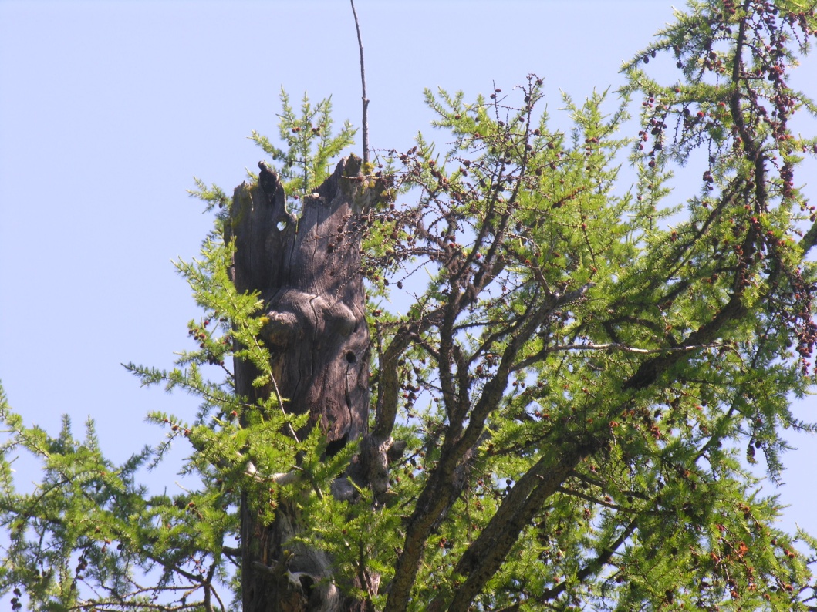

Figure 3. Male Williamson's Sapsucker at top of western larch vet.

3.3 Nest re-occupancy

Forty-nine Williamson's Sapsucker nest trees have been found in the East Kootenay, not including the new nest tree, found in 2012. Of this total, six pairs alternated between two suitable nest trees on the same territory, making 43 confirmed nesting territories, in which nest trees have been found. Of those 43 territories, 40 were checked for re-occupancy in 2012. Nine of 40 (22.5%) were re-occupied in 2012.

The new nest (WNE048) was approximately 525 m from WNE034. If we assume this is the same pair in another part of its territory at South Star trails, re-occupancy was 10 of 40, or 25%. Eight of ten territories occupied in 2011 were again occupied in 2012.

3.4 Logistics

Including travel time, it took approximately 285 person hours to survey 248 cpb points in the EK in 2012. A total of 22.18 person hours were spent accessing points on foot (one-way). Fifteen points labeled as “road” access required walking. One of the points labeled as “non-roaded” was accessible by vehicle. Bike access accounted for about 20 minutes of the total time.

Nest searches took approximately 24 person hours and over 26 person hours were spent at nests during re-occupancy checks. These values do not include travel time to and from the nest sites.

We travelled 5,903 km to complete the cpbs, the nest searches, and one-third of the nest re-occupancy checks.

While we do not have the data for travel time and mileage of Ted Antifeau during his nest re-occupancy checks, we have calculated that he spent a total of 29.7 hours at nest sites.

4.0 DISCUSSION

4.1 Call playback surveys

In the East Kootenay, “the primary purpose of the random points is to improve the list frame” (Ainsworth and Pickard 2012). Work carried out using random selection of cpb points in the past three years has failed to accomplish this. Knowledge about the list frame has not been substantially improved - new nests were found primarily through incidental observations and at non-randomly selected sites. We have identified several major problems with the methodology used for monitoring Williamson's Sapsucker in the East Kootenay. These include the following:

A. Definition of AO and location of cpb stations:

i. There are approximately six to eight distinct nesting areas mapped in the Williamson`s Sapsucker Recovery Strategy (Env. Canada 2010) which have been amalgamated into one, large AO (Figure 4) (after Gyug 2010). While this amalgamation may have practical benefits (i.e. to guide timber harvest operations), it likely includes many unsuitable areas for Williamson`s Sapsucker. Random call playback stations provided by Environment Canada were drawn from this large, provisional AO, and that likely contributed to the extremely low detection rate. An alternate approach would be to clearly delineate multiple AO boundaries in the East Kootenay by following approaches used in the Merritt-Princeton and Okanagan-Boundary AOs. That is, begin with targeted searches to find birds, and then systematically sample in a radiating fashion away from these concentrations to determine where detections minimize. Subsequently, cpb stations could be randomly positioned within these well-defined AOs, combined with opportunistic sampling of adjacent areas to identify new areas, and detect trends. Currently the sampling resolution is too coarse compared to the low density of birds in this region, and little information is being obtained.

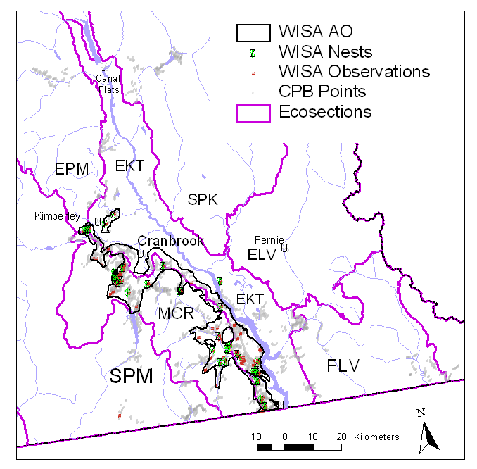

Figure 4. Provisional Area of Occupancy for Williamson's Sapsucker in East Kootenay as of 2009 (after Gyug 2010).

ii. Birds were detected at eight random cpb stations, three of which were located in previously known territories (Ohanjanian et al. 2006, 2008). Under the dual frame sampling protocol, random sites in the area frame should not already be included on the list frame (Ainsworth and Pickard 2012). Selection of future random cpb stations should confirm that this is validated.

B. Habitat stratification:

To identify Critical Habitat, the draft Williamson's Sapsucker Recovery Strategy states the need to “develop and refine GIS Habitat Models for the three Areas of Occupancy, and selectively ground-truth for accuracy” (Env. Can 2010). Ground-truthing has been carried out and there are several issues that arise, which include:

i. Inaccurate mapping. The vegetation mapping and databases from which the stratification was derived is flawed. For example, sites labeled VR or VN (rated as “Very Low”) ranged from good habitat (eg. mature forest with large western larch vets) to totally unsuitable habitat (eg. dense, young forest with small diameter spruce and larch, and no decay features). “Extra” points (seed tree cuts) varied in species and size of seed trees left, as well as in the presence (or absence) of decay characteristics. Furthermore, the mapping is based on timber harvest classifications, not on classifications that are ecologically relevant to Williamson's Sapsucker.

ii. Habitat model suitability and habitat classification. Birds were detected at stations that were ranked as “Low” and “Very low” in the East Kootenay. Because we have limited productivity data for the EK, we do not know if these habitat categories are suitable for this region. Furthermore, the value of aspen stands has not been evaluated, and productivity of Williamson's Sapsucker nesting in those versus mature larch stands is not known.

iii. Stand structure definitions. The categories themselves: MatFor/h, Part Cut, etc (see Table 1), were too general and of little use in describing stand attributes. MatFor/harvested was the predominant category at sites in the East Kootenay. However, within this category the variability in stem densities, the species mix and dbh among sites was very high. Note, however, that the stand structure definitions are of the cpb station, and may not reflect the Williamson's Sapsucker habitat that is being used.

C. Detectability:

i. Until p(detection) is determined, we will be unable to assess population size, nor monitor population trends over time. Preliminary work to determine an estimate of probability of detection through repeat visits was started in 2010, however, this sampling effort was too small to develop any rigorous detection estimates (Ohanjanian 2010). We recommend continuing this component of the work to improve our knowledge of p(detection).

ii. We suggest that future work include an assessment of detection as a function of distance, as recommended by Ainsworth and Pickard (2012).

4.2 New nest searches

Despite intense searching (24 hrs) none of the four potential new nests were found. Precipitation in the weeks corresponding to hatching times in 2012 was 2 to 3 times greater than normal (Env. Can. 2012). Cold weather and very hard rains likely effected ant availability for the Williamson's Sapsuckers during this period. Anecdotal information provided by naturalists indicated that most bluebird nest boxes at the same time failed - young were found dead, probably from starvation (S. Hansen, pers. comm.). This suggests that potential forage limitations and poor thermal conditions could have been a contributing factor.

4.3 Nest re-occupancy

Future work examining nest re-occupancy must employ a consistent methodology. Due to budgetary constraints, approximately two thirds of the known territories were checked in April and early May, and one third were checked in June. The problem with this is that those nests checked in June may have been occupied earlier, but failed. This also illustrates the need to follow-up on all detections, throughout the nesting period, from territory establishment to fledging. Ultimately, we need to be able to estimate productivity and survivorship to truly understand population trends. Because we have no productivity estimate (nor survivorship for that matter), we are unable to assess the implications that failed nests may have on population size.

4.3 Logistics

Travel distances in the East Kootenay are large and driving consumes a great deal of time and budget. Concentrating monitoring efforts over a smaller survey area in future work could decrease this.

Similarly, roads that appeared on maps and satellite pictures to be drivable often were not. Fifteen stations mistakenly labeled as “road” had to be accessed on foot.. The total time spent walking to cpb stations (including those labeled correctly) amounted to almost 3 person days .

5.0 RECOMMENDATIONS

We recommend the following:

a) Concentrate monitoring efforts in those areas where there is a higher density of Williamson's Sapsuckers. Apply random sampling in the vicinity of these higher densities to better define the AO. Once this has been well established, expand sampling effort outwards from these regions.

b) Conduct repeat visits to cpb stations to estimate detectability, with the ultimate goal of finding more birds.

c) Examine the statistical implications of using an adaptive sampling approach, whereby field crews can strategically add cpb stations in areas of suitable habitat or in areas adjacent to higher occupation sites according to their field experience.

d) Find mapping and data sources other than the VRI database to assist in stratification.

e) Refine the habitat model for the East Kootenay.

f) Continue to sample early in breeding season, during territory establishment and nest construction.

6.0 LITERATURE CITED

Ainsworth, L. and D. Pickard. 2012. Statistical Analysis of 2011 data to Inform the Adaptive Monitoring Framework (AMF) for Assessing the Status and Trend of Williamson’s Sapsucker (WISA). Draft Prepared by ESSA Technologies Ltd., Vancouver, B.C. for Ian Parnell, Environment Canada-Canadian Wildlife Service.

Braumandl, T.F. and M.P. Curran 1992. A field guide for site identification and interpretation for the Nelson Forest Region. B.C. Min. of Forests, Nelson

Environment Canada. 2010. Recovery Strategy for the Williamson’s Sapsucker (Sphyrapicus thyroideus) in Canada [Draft]. Species at Risk Act Recovery Strategy Series. Environment Canada, Ottawa. xx + XX pp.

FIA. 2006. Information Gathering and Management Component, Resource Inventories Activity Area, Wildlife and Wildlife Habitat Activities, specifically Williamson's Sapsucker Inventory, Stand-level Habitat Assessment and Nest Productivity Assessment Standards. Forest Investment Account. BC Ministry of Forests and Range, Victoria.

Gyug, L. 2010. Williamson’s Sapsucker Final Species Account for Species-habitat Model for the East Kootenay. Report prepared for Ecosystems Branch, Ministry of Environment, Victoria, BC, and Canadian Wildlife Service, Environment Canada, Delta, BC

Marmorek, D. and D. Pickard. 2010. Adaptive Monitoring Framework (AMF) for Assessing the Status and Trend of Williamson’s Sapsucker (WISA). Draft. Prep. for Environment Canada, Delta BC,

Ohanjanian, P. 2010. Williamson's Sapsucker (Sphyrapicus thyroideus): Baseline Population Monitoring in the East Kootenay. Report for Environment Canada. 11 pp

Ohanjanian, P. 2011. Monitoring of Williamson’s Sapsucker, Sphyrapicus thyroideus, in the East Kootenay Area of Occupation, 2011. Report for Environment Canada. 9 pp

Ohanjanian, P., I. A, Manley, and P. Davidson. 2006. Williamson’s Sapsucker in the East Kootenay Region: Results of 2006 Inventory. Report for Tembec Industries, Inc., B.C. Forest Investment Account and B.C. Min. of Environment. 23 pp

Ohanjanian, P., P. Davidson, S. Hansen and J. Beare. 2008. Williamson’s Sapsucker in the East Kootenay Region: Results of 2008 Inventory. Report for Tembec Industries, Inc., B.C. Forest Investment Account and B.C. Min. of Environment. 43 pp

Personal Communications

Ted Antifeau, Biologist, BC Ministry of Natural Resource Operations, Nelson

Two thirds of the nest re-occupancy checks were carried out by T. Antifeau, Min. of Forests, Lands and Natural Resource Operations, Nelson, BC
In reality, only 13 of 20 points were located in Seed Tree cuts. Two sites were in Partial Cuts > 5 years old, 2 sites were in Partial Cuts <5 years old, 1 was in a Clear Cut with Reserves, and 2 sites were on the periphery of Seed Tree cuts with mature forest (previously harvested) and mid-seral Douglas fir on the other.
NOTE: The stand structure classifications describe the habitat at the cpb station and not necessarily the habitats used by Williamson's Sapsuckers.

